Lab 2 - Passive and Active Information Gathering. OSINT Tools (Shodan, Maltego, theHarvester)
Tursynbay Mansur CS - 2428

Objectives
In this lab, you will complete the following objectives:
- To learn methods of passive and active information gathering using basic OSINT tools.

Background / Scenario
Students will work with WHOIS, DNS queries, Google Dorking, and explore public data using Shodan and theHarvester.

Required Resources
- Kali VM
- TheHarvester (pre-installed in Kali Linux)
- Internet access
- For Windows users: Use PowerShell or install WSL (Windows Subsystem for Linux).
- Access to these websites:
WHOIS Lookup (online service)
Shodan

Instructions

Part 1: Passive Information Gathering

Task 1: Domain Analysis Using WHOIS
Aim: Find out who registered a domain, when it was created, and other publicly available information.
Steps:
- Open your browser and go to https://who.is/
- Enter any domain (e.g., example.com) in the search box.
- Identify the following details in the results:
- Domain owner (if not hidden) 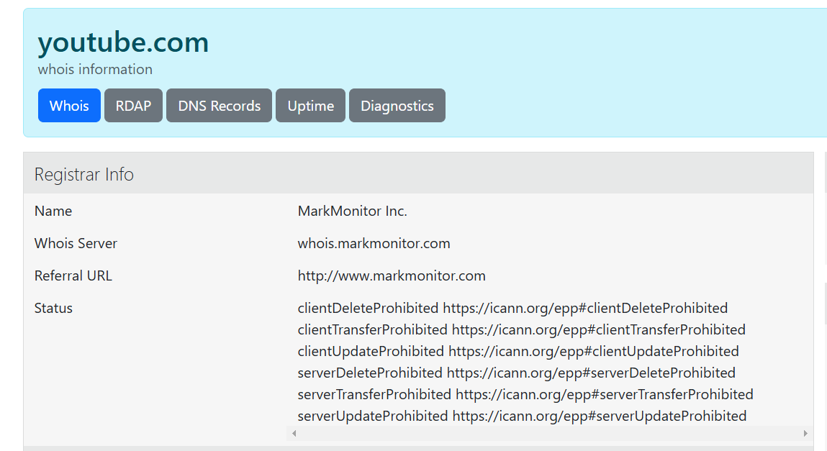
- Registration and expiration dates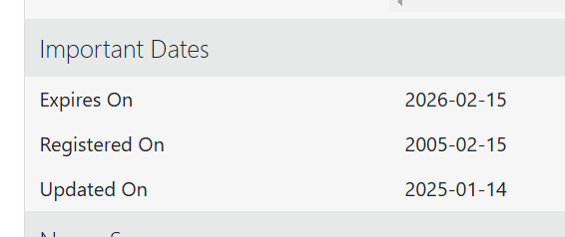
- Name servers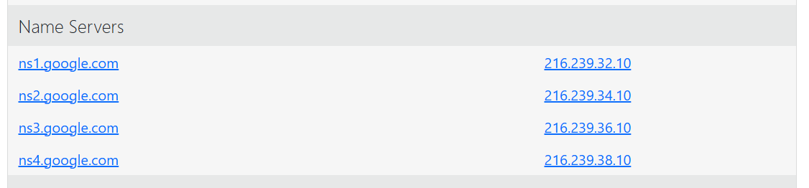
- Domain IP address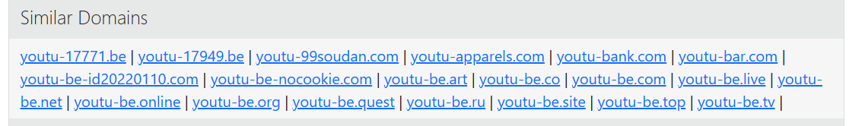
Alternative method (via terminal):
If using Kali Linux or macOS, open the terminal and run:
whois google.com
(Replace google.com with the target site. For example: astanait.edu.kz)
After extracting domain data answer the questions below:
- What ownership information was found? 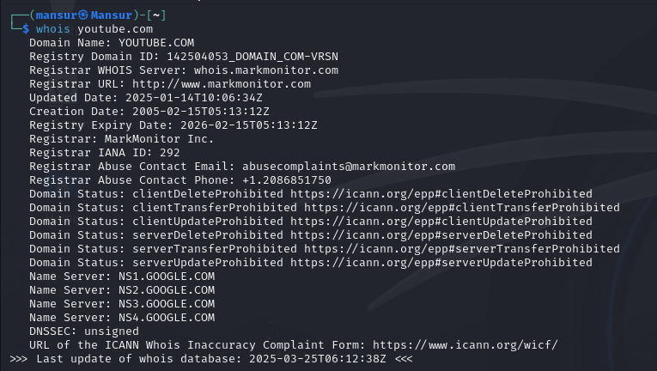
- Why are some details hidden?
Privacy Protection: Many registrars offer WHOIS privacy to protect personal details
Security Reasons: Hiding contact information helps prevent spam, phishing attempts, and domain hijacking

Task 2: DNS Queries and Finding IP Addresses
Goal: Find the website’s IP address and check which mail servers are associated with the domain.
Steps:
Method 1: Using online tools
- Open https://mxtoolbox.com/
- Enter the domain (e.g., google.com).
- Select DNS Lookup and MX Lookup (to find mail servers). 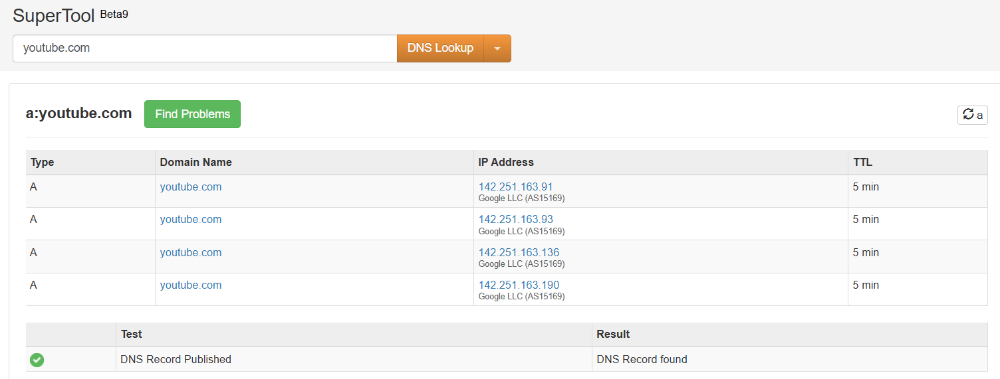 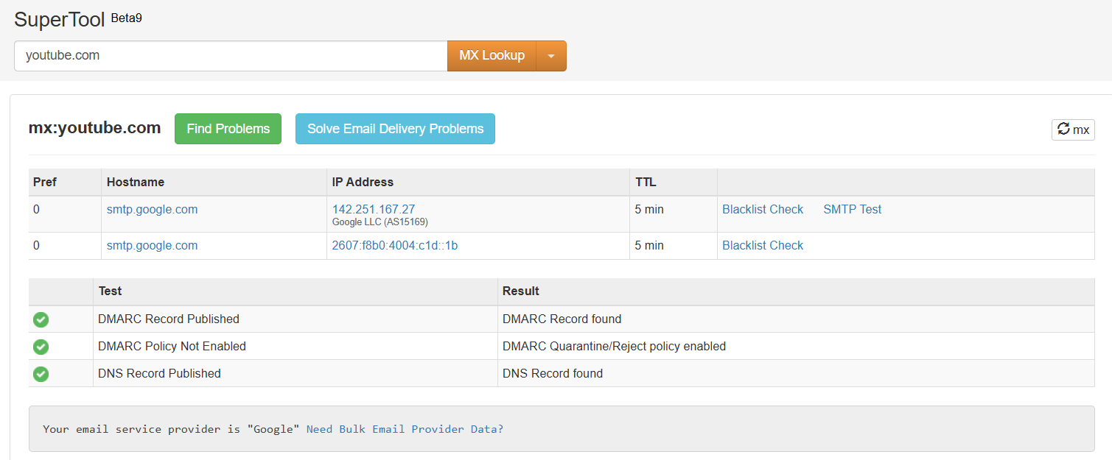
Method 2: Using the command line
For Windows, open Command Prompt (cmd) and run:
nslookup google.com 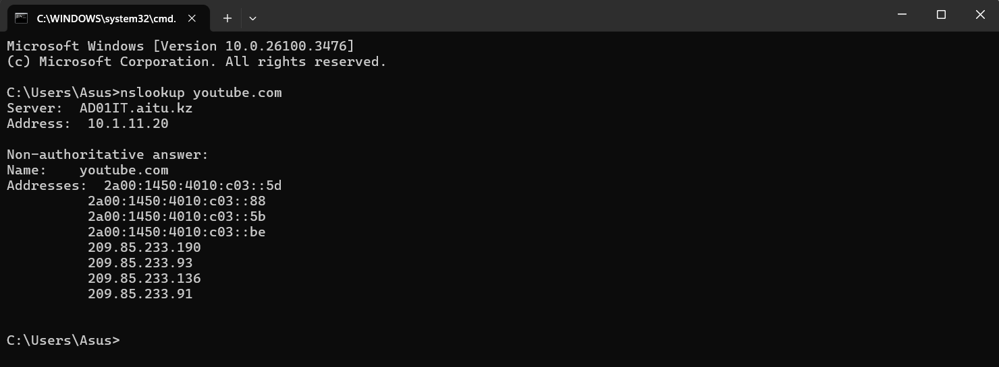
For Linux/macOS, open Terminal and run:
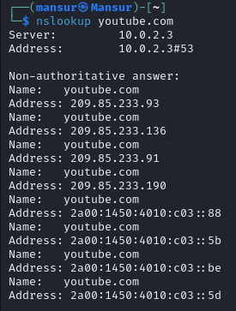
nslookup google.com
Note the returned IP address.
Additional mail server check:
nslookup -type=mx google.com
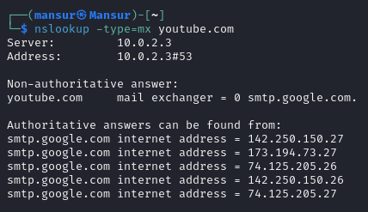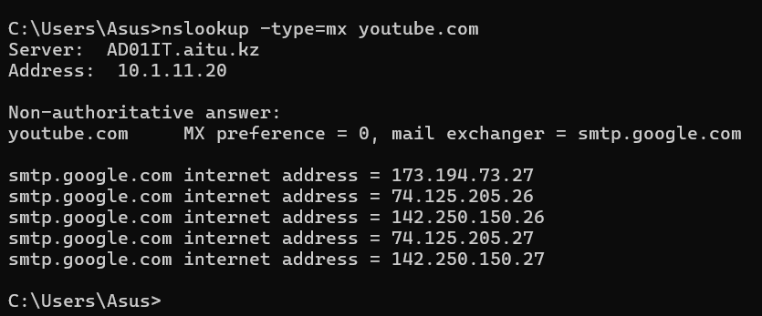
(Replace google.com with the target domain.)
Why is it important to know a website’s IP address?
It helps fix connection issues, bypass blocks, and find server details

How can an attacker use this information?
They can overload the server (DDoS), find weak spots, or trick owners into giving access

Part 2: Active Information Gathering

Task 3: Google Dorking
Goal: Find hidden files and directories on a website.
Steps:
- Open Google and try the following search queries:
Find all PDF files on a website:
site:google.com filetype:pdf
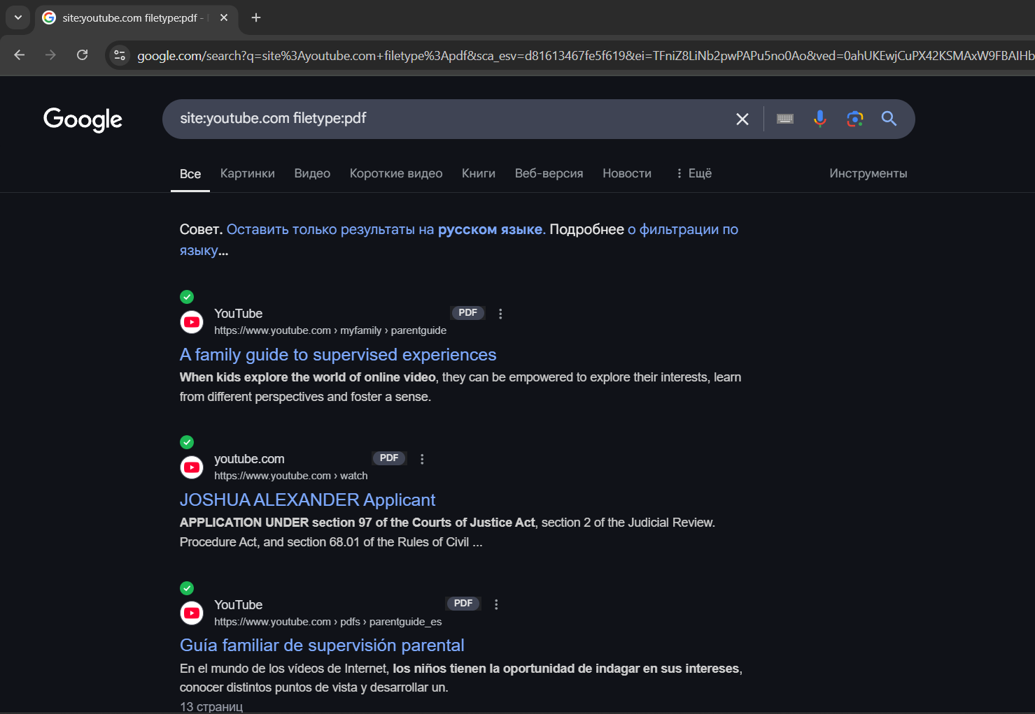
Check for open directories:
site:google.com intitle:"index of"
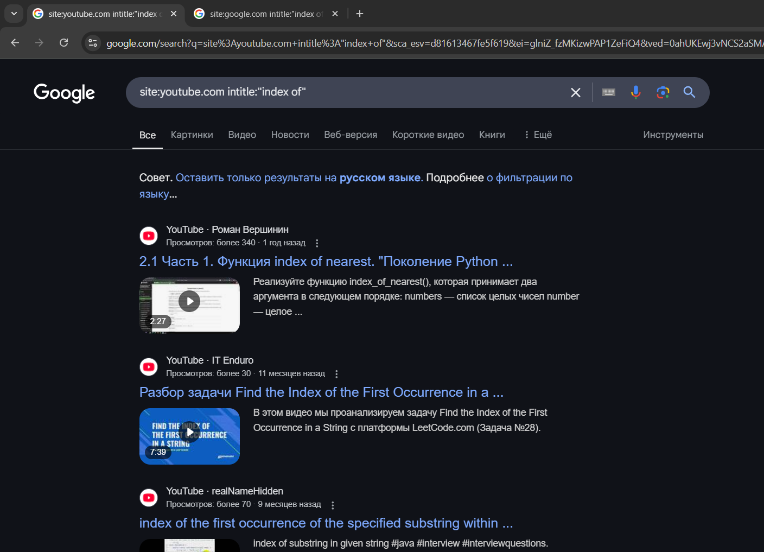
Search for email addresses:
site:google.com "email"
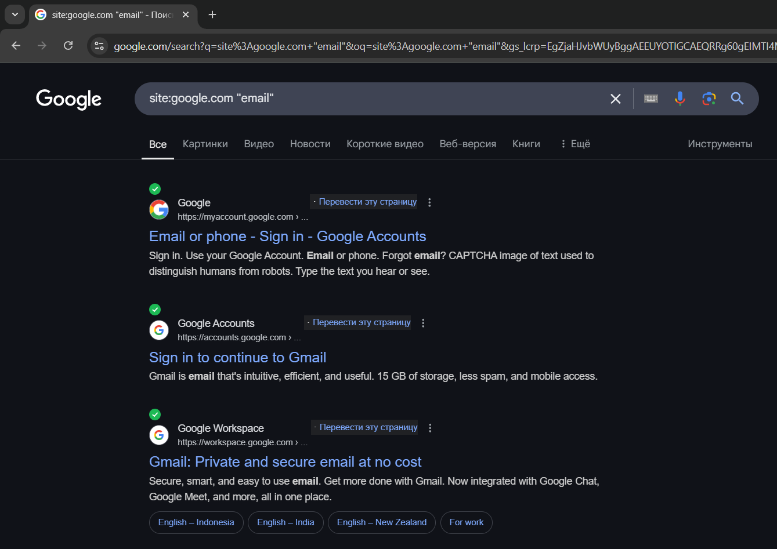
What risks are associated with publicly accessible files?
Private data can leak
Hackers may access or misuse files
How can organizations protect against Google Dorking?
Restrict access with passwords
Remove unnecessary files

Task 4: Finding Devices Online with Shodan
Goal: Discover publicly accessible servers, cameras, and devices on the internet.
Steps:
- Go to https://www.shodan.io/
- Type apache and press Enter.
- Find web servers running Apache. 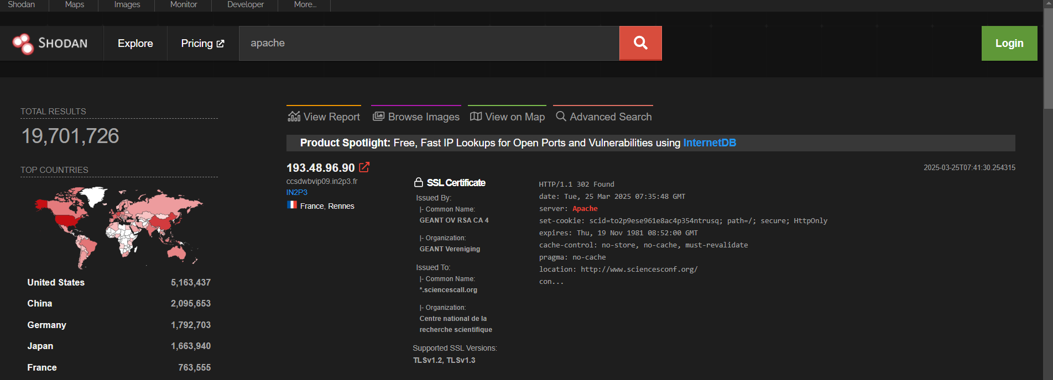
- Try searching for devices in a specific country (e.g., Germany):
country:DE
Record some discovered IP addresses and services.
Why is Shodan useful for security testing?
Finds exposed devices and services
Helps identify security risks
Detects outdated software with vulnerabilities
What types of devices are most commonly exposed online?
Security cameras and webcams
Routers and network devices
IoT devices (smart TVs, printers, home automation)
Servers and databases

Task 5: Collecting Information with theHarvester
Goal: Find email addresses and subdomains of a company.
Steps:
- Open a terminal in Kali Linux.
- Run the following command:
theHarvester -d example.com -l 50 -b google
- Record any discovered email addresses and subdomains. 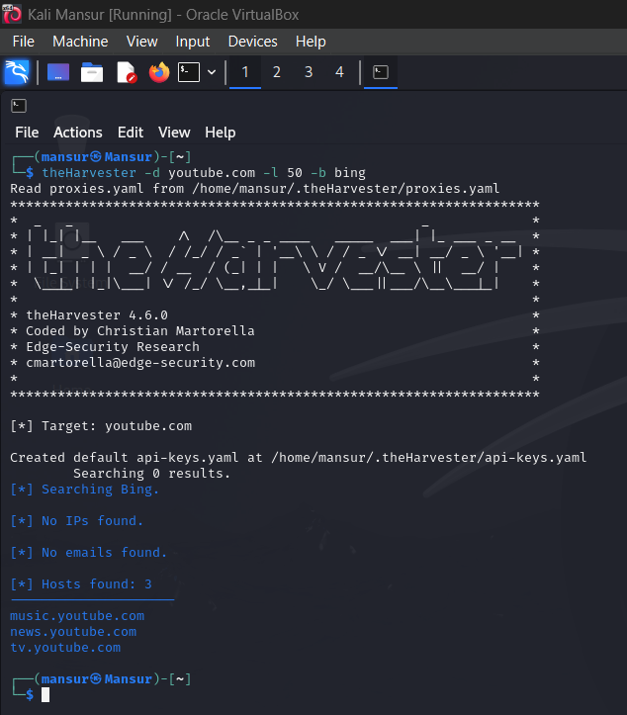
- How can an attacker exploit discovered email addresses?
Phishing to steal passwords
Sending spam or scams
- What precautions should an organization take?
Use email filters
Enable multi-factor authentication (MFA)
Keep emails private

